Rokaly Kriszta

30322

**Laboratory Project**

**1. Project Summary**

The goal of this project was to create a website that allows users to receive recommendations for TV shows based on their preferred genre, medium, and IMDb score. The necessary data that makes this possible is being stored in a database in MySql Workbench.

The database contains 5 tables each with a unique purpose. The Shows table contains the data related to the shows that are available in the database at the moment. It has the following columns: Shows_Id, Title, Score, Medium_Id and Genre_Id. The Medium table keeps track of the different mediums: Traditional Tv (having the Med_Id 1), Animation (having the Med_Id 2) and Anime (having the Med_Id 3). The Genres table stores the different genres (Genre_Name) and associates a Medium_Id to each as the genres are unique to their respective medium (each combination means a separate Genre_Id). The database also contains a User table that contains all the user data: User_Id, User_Name, Password and their Role. The Recommendations table keeps track of what show each user has been recommended by storing the Rec_Id, the User_Id, the Show_Id and a special column called Recommended, that signifies if the user liked the recommendation and added it to their Watch Later list.

The website that utilizes the database described has a login system that identifies the user by their username and password and immediately checks for their roles. If the login is successful the user will have access to the main site, where they are greeted by a welcome message and where they can choose their preferences with the help of select lists. The menu bar on the top of the site looks different for the users and for the administrators. While the user has access only to the personalized quiz, to their watchlist where they saved the recommendations they liked and to the logout, the administrator has access to more options. Aside from the ones already mentioned, the administrator can select currently available TV show recommendation options, can add new TV shows to the database through the website, can edit already existing ones or delete the ones that are not preferable to have anymore (select, insert, update, delete).

All in all, the database together with the website is something that can help everyone with finding shows that they can enjoy in their spare time. The website utilizes many languages such as html, css, php, sql and javascript, while also being connected to a database that has tables, views and diagrams, all for the purposes of helping the management of the site and providing the users with the service they have signed up for.

**2. Database codes**

Code for database:

CREATE DATABASE IF NOT EXISTS Project;

USE Project;

DROP TABLE IF EXISTS Shows;

CREATE TABLE Shows (

Shows_Id INT NOT NULL PRIMARY KEY,

Title VARCHAR(75) NOT NULL,

Score INT NOT NULL,

Medium_Id INT NOT NULL,

Genre_Id INT NOT NULL

);

DROP TABLE IF EXISTS Medium;

CREATE TABLE Medium (

Med_Id INT NOT NULL PRIMARY KEY,

Type VARCHAR(50) NOT NULL

);

DROP TABLE IF EXISTS Genres;

CREATE TABLE Genres (

Genre_Id INT NOT NULL PRIMARY KEY,

Genre_Name VARCHAR(75) NOT NULL,

Medium_Id INT NOT NULL

);

DROP TABLE IF EXISTS User;

CREATE TABLE User (

User_Id INT NOT NULL PRIMARY KEY,

User_Name VARCHAR(50) NOT NULL,

Password VARCHAR(50) NOT NULL,

Role VARCHAR(50) NOT NULL

);

DROP TABLE IF EXISTS Recommendations;

CREATE TABLE Recommendations (

Rec_Id INT NOT NULL PRIMARY KEY,

User_Id INT NOT NULL,

Show_Id INT NOT NULL,

Recommended TINYINT(1) DEFAULT 0

);

Connections between tables:

ALTER TABLE Shows

ADD FOREIGN KEY (Medium_Id) REFERENCES Medium(Med_Id);

ALTER TABLE Shows

ADD FOREIGN KEY (Genre_Id) REFERENCES Genres(Genre_Id);

ALTER TABLE Genres

ADD FOREIGN KEY (Medium_Id) REFERENCES Medium(Med_Id);

ALTER TABLE Recommendations

ADD FOREIGN KEY (User_Id) REFERENCES User(User_Id);

ALTER TABLE Recommendations

ADD FOREIGN KEY (Show_Id) REFERENCES Shows(Shows_Id);

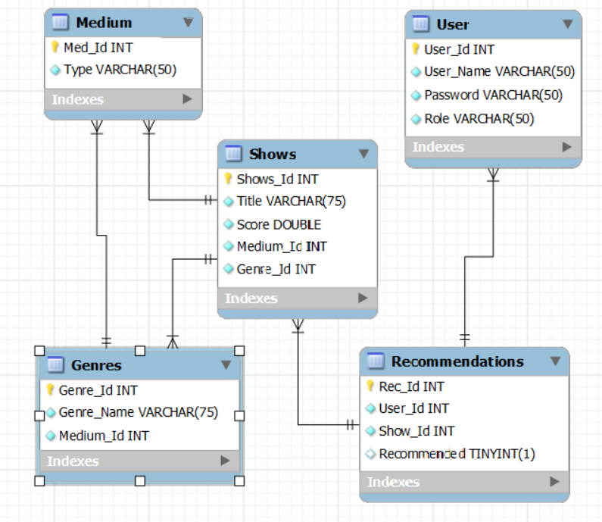Codes for the 7 views available:

- 3 catalogues to keep track of shows/medium

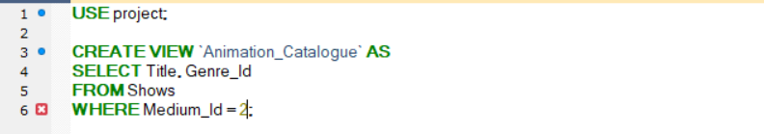

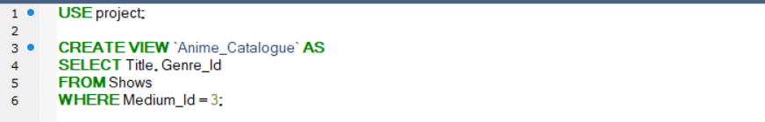

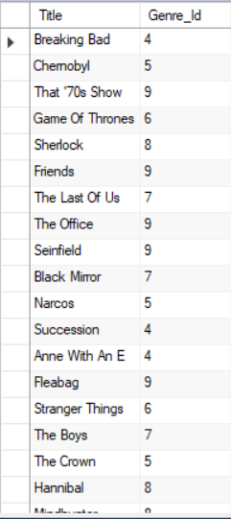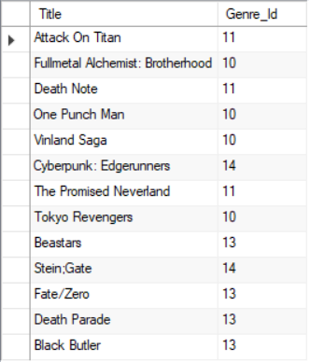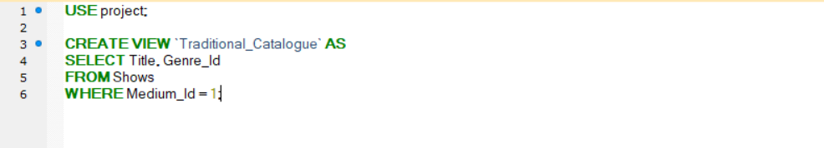

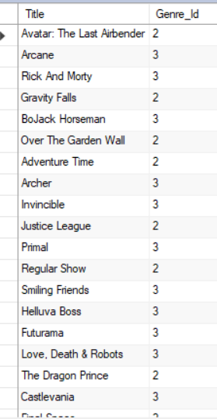

- current top 25 shows in the database

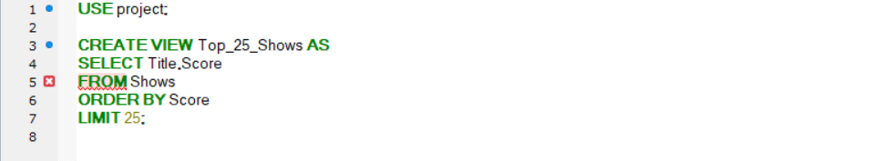

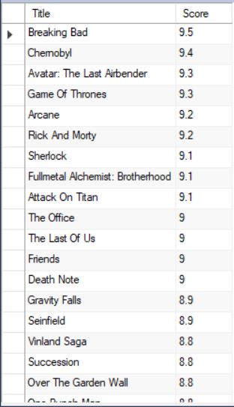

- a view to keep track of active recommendations/user

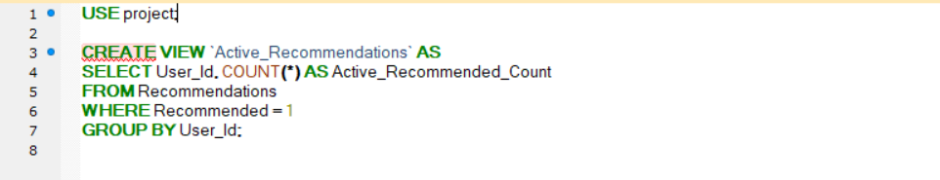

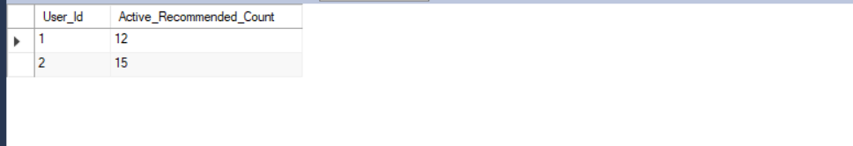

- a view to show every User_Id, User_Name and Show_Id combination

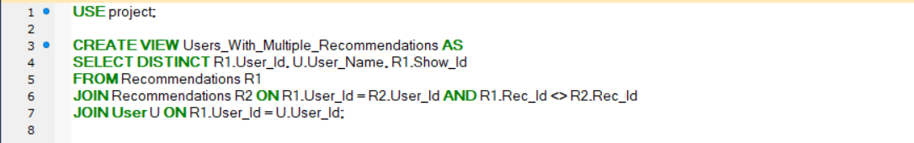

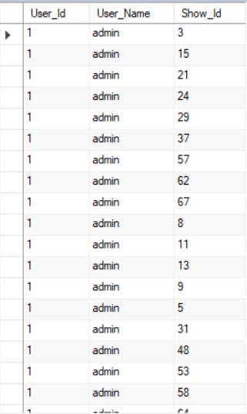

- since recommended is the only column in the database that is not set to “NOT NULL” there is a view to see if any errors have been made and there is a recommended row where we have a NULL value

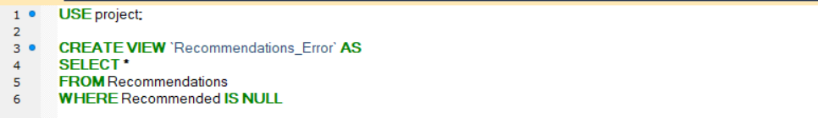

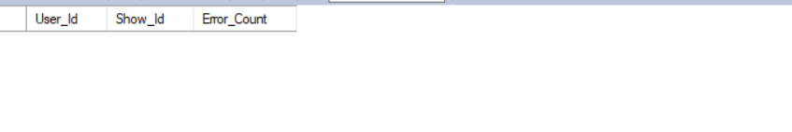

**3. Website Preview**

Login page:

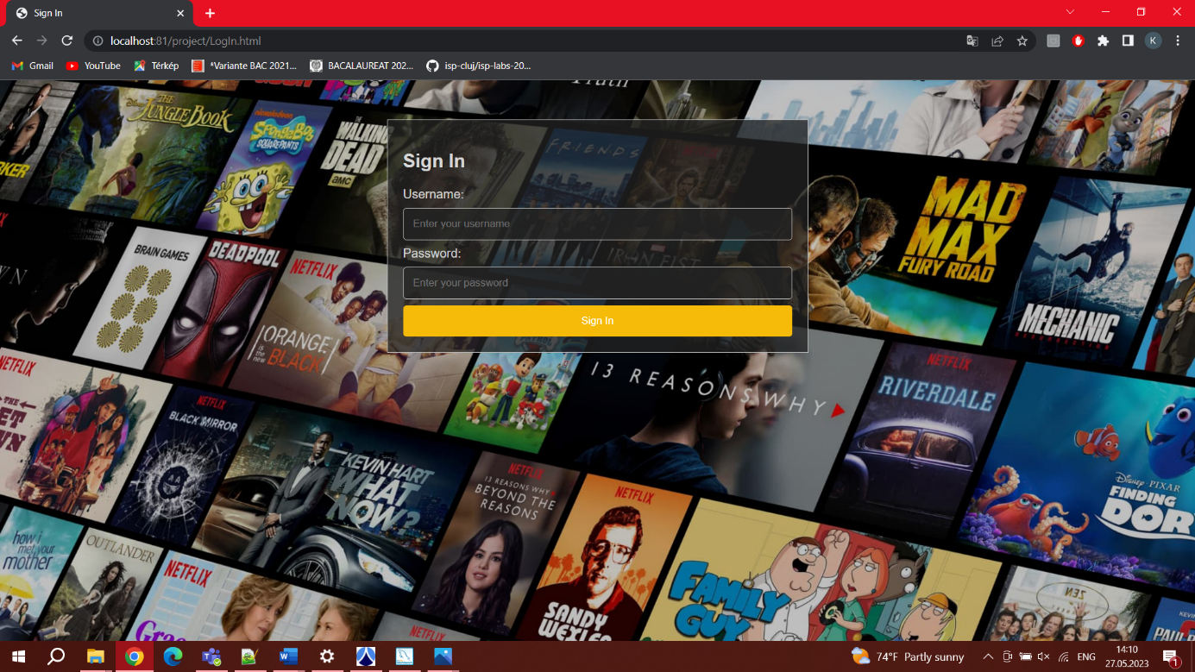

Main page for user:

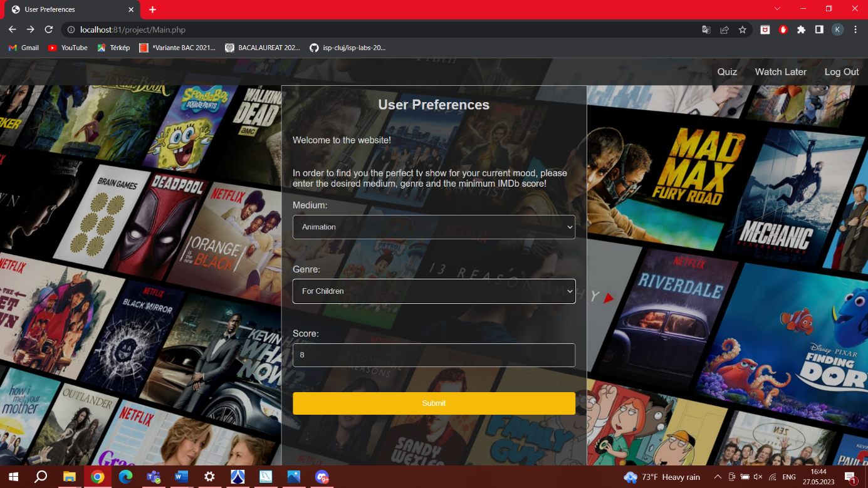

Recommendation for user based on preferences:

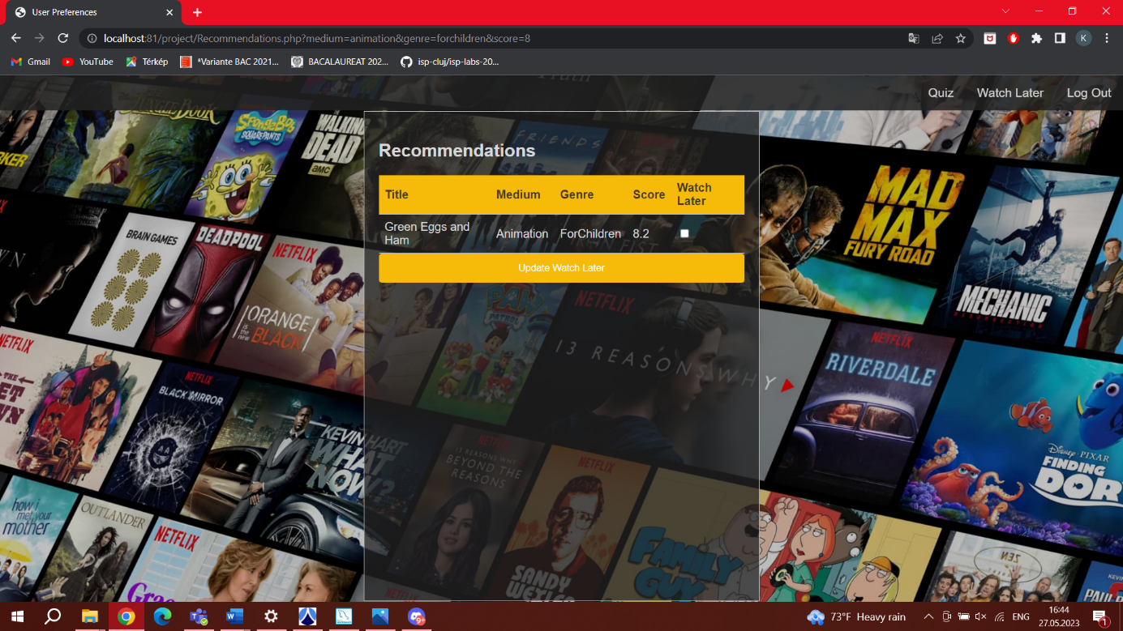

Watch later page for user:

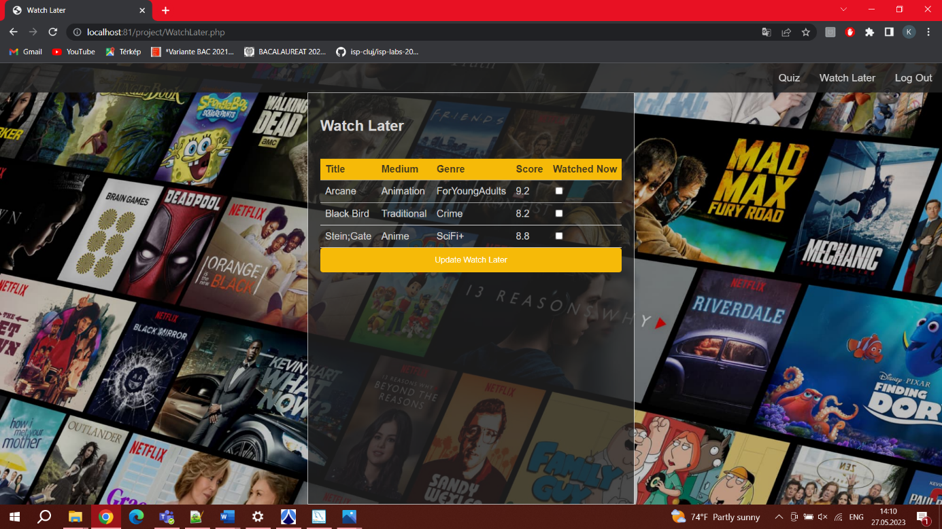

Main page for admin:

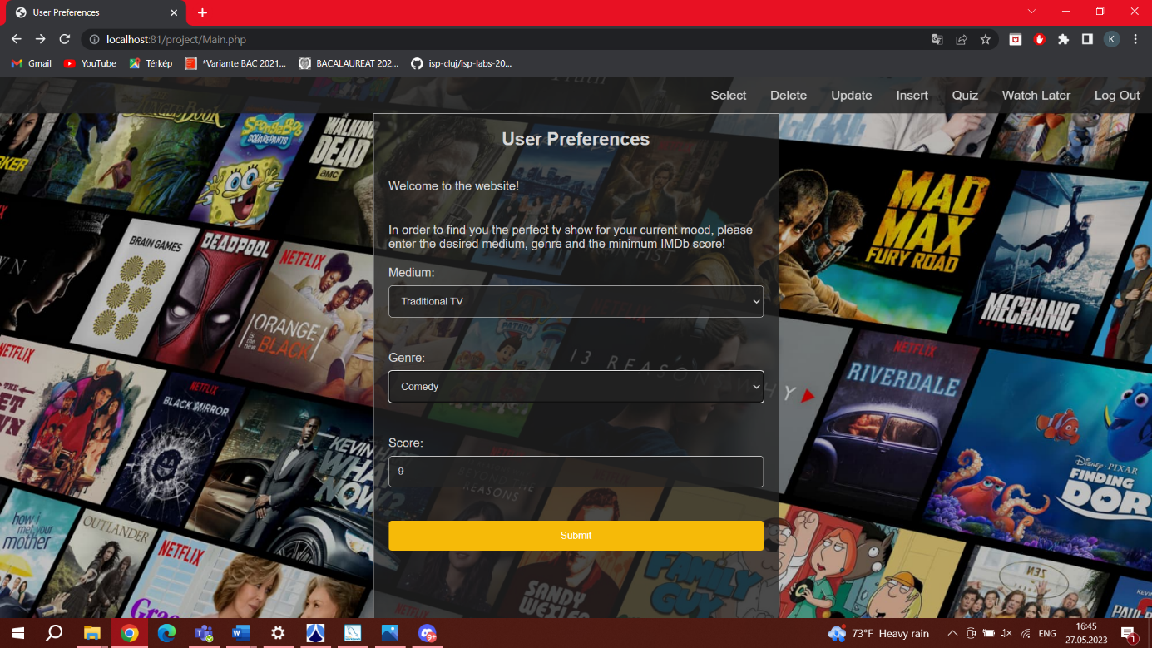

Recommendation for admin based on preferences:

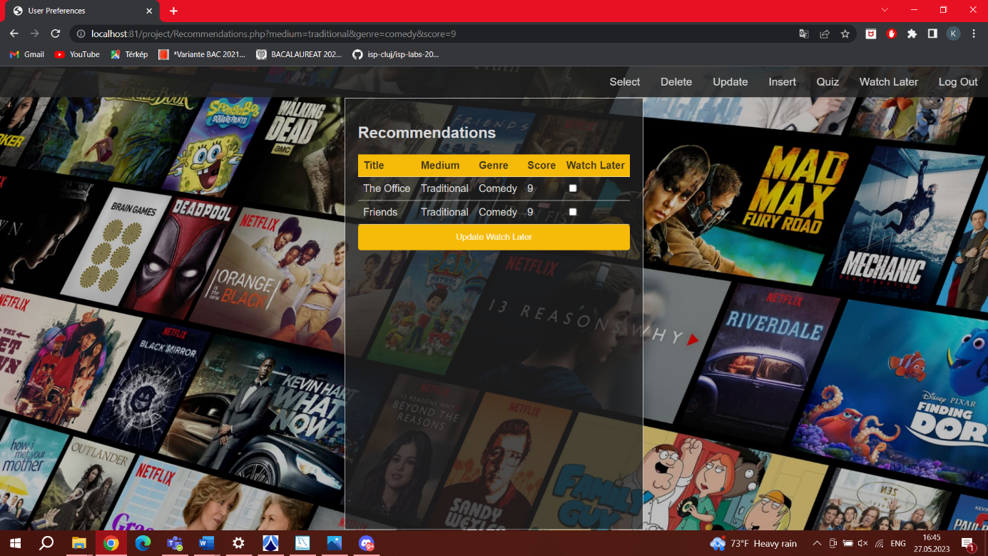

Select page for admin:

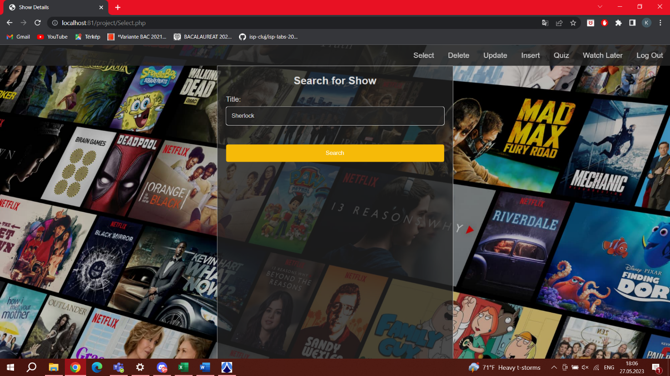

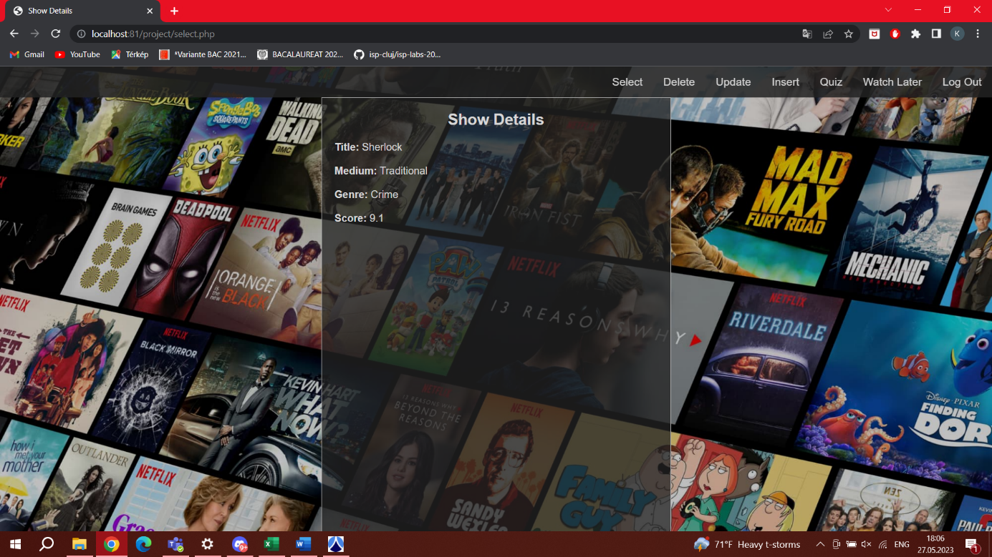

Insert page for admin:

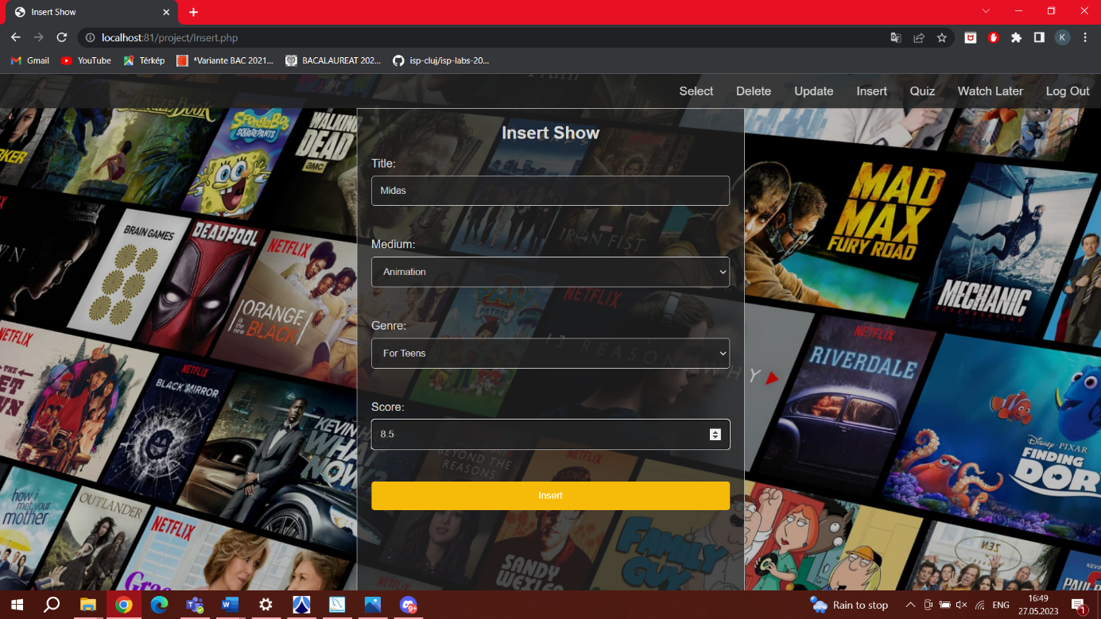

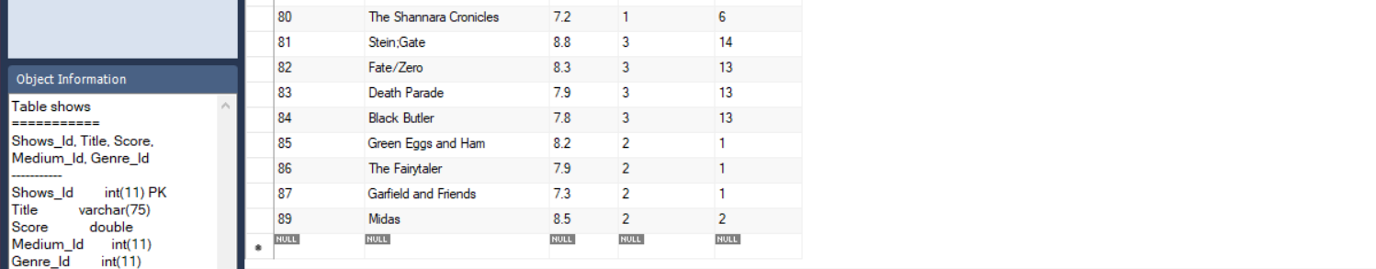

Update page for admin:

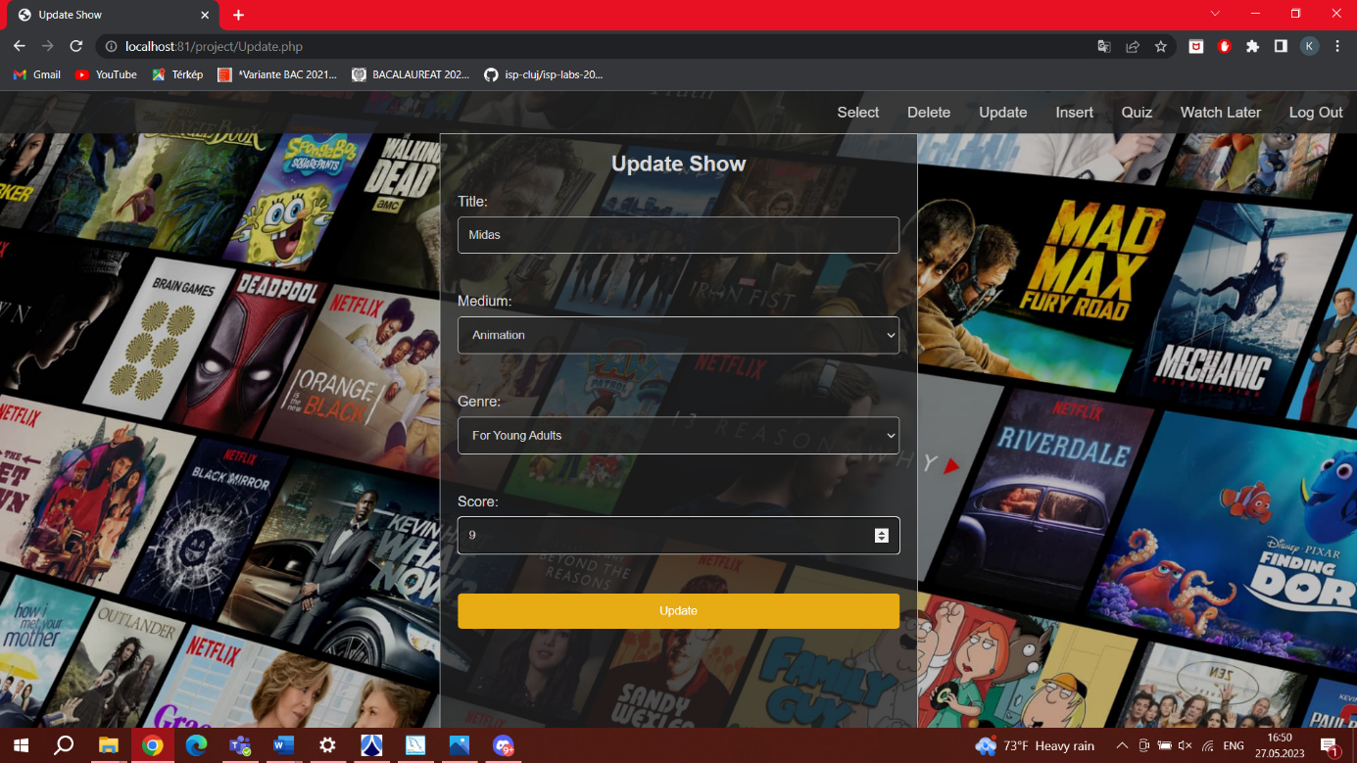

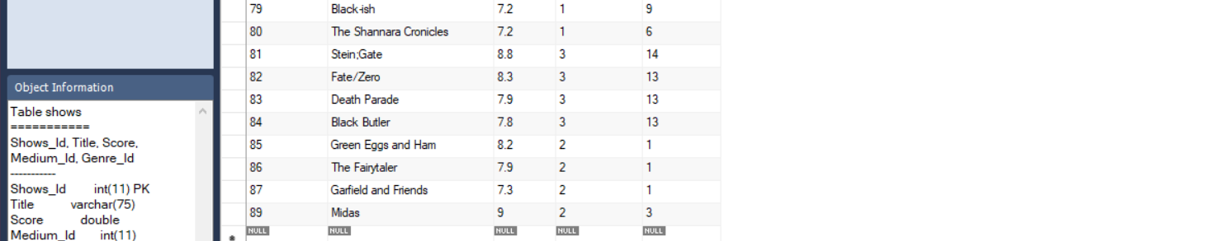

Delete page for admin:

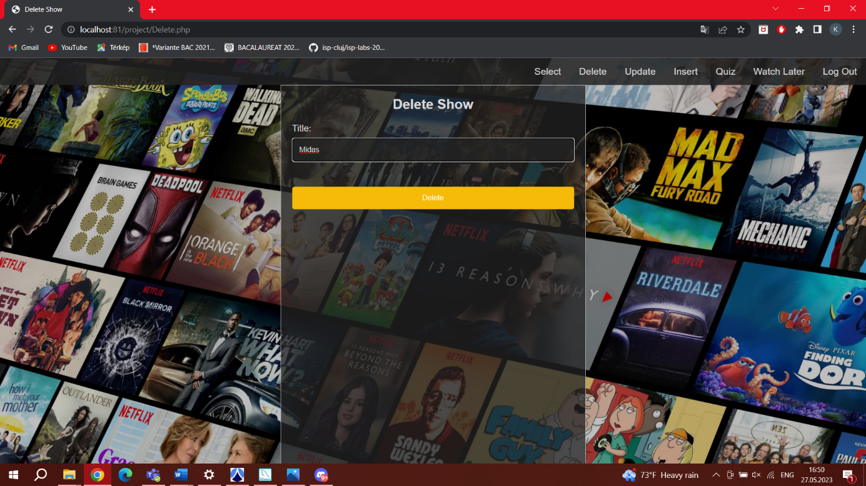

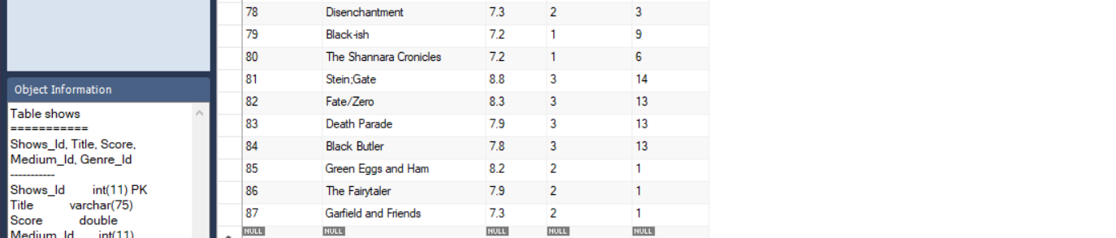

Watch later page for admin:

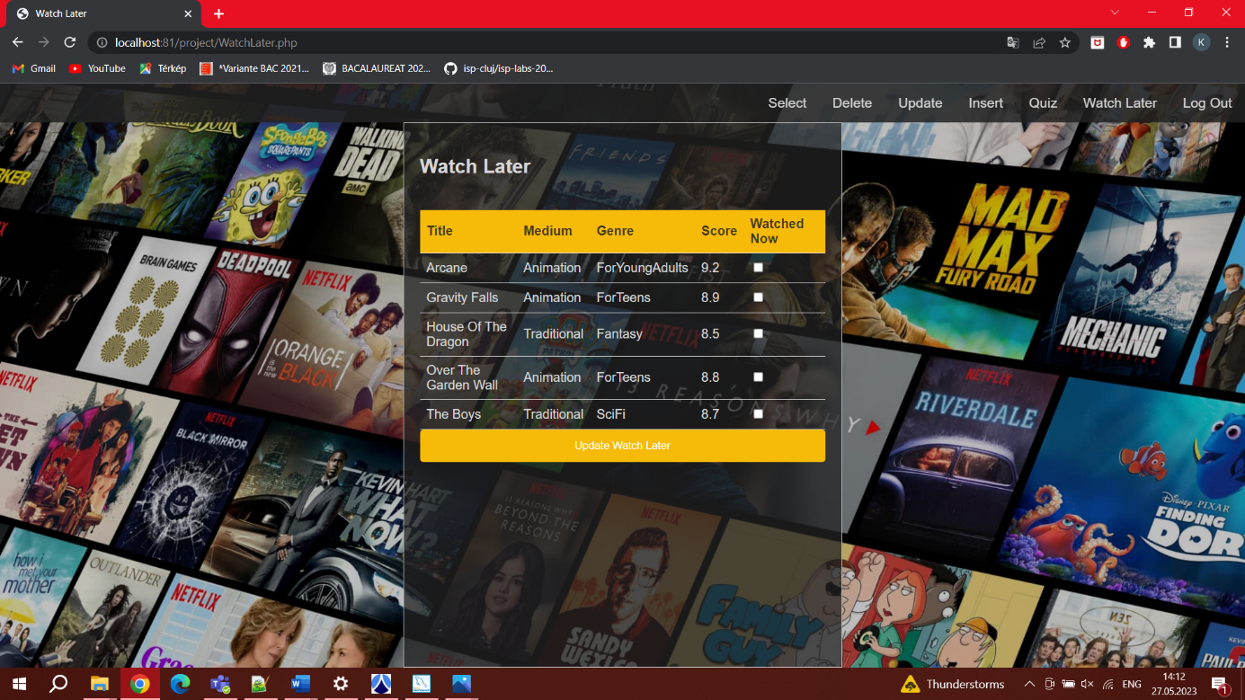

SQL codes in the files of the website:

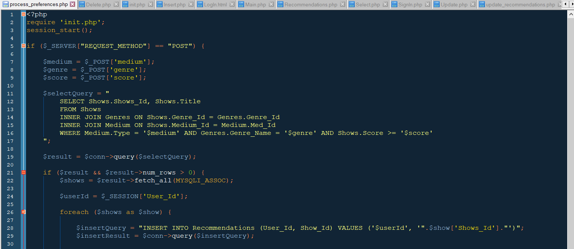

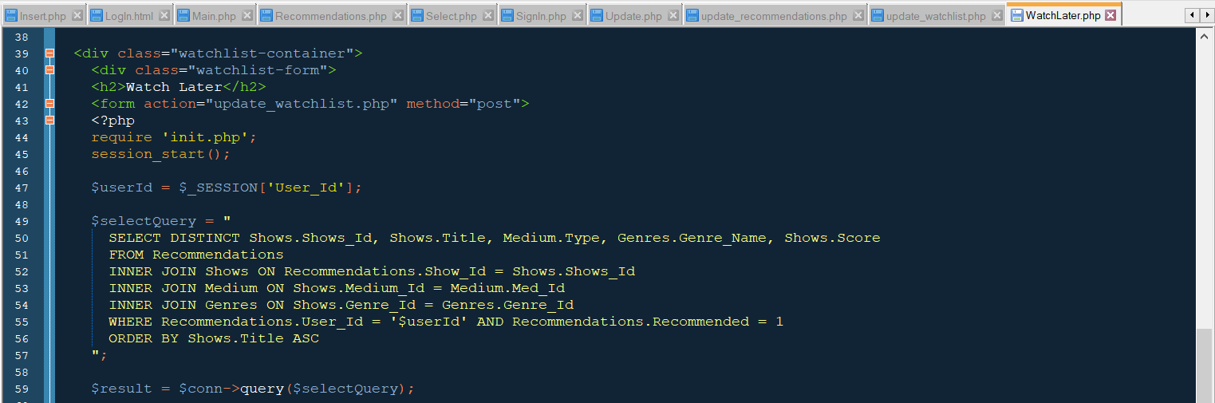

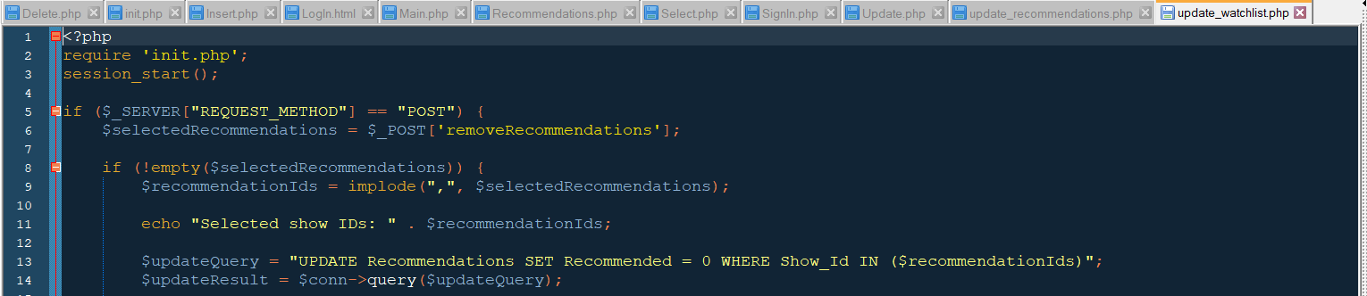

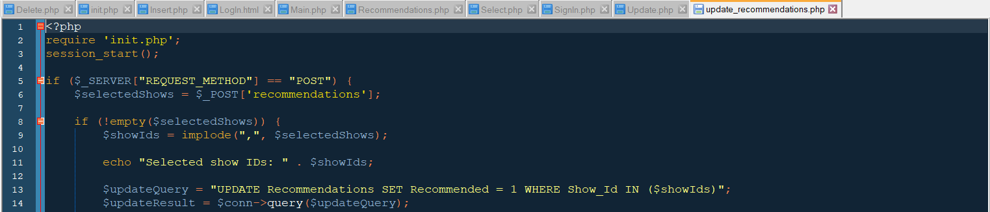

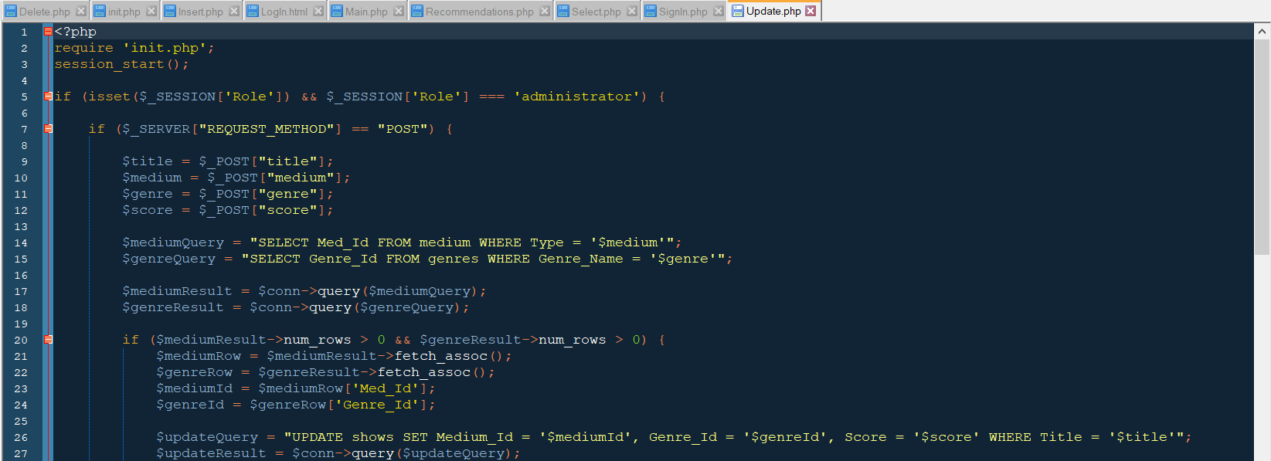

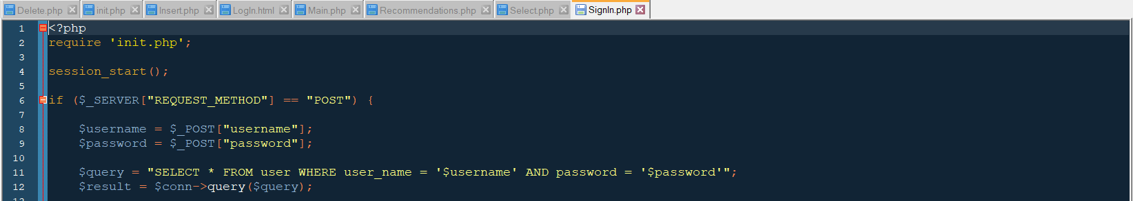

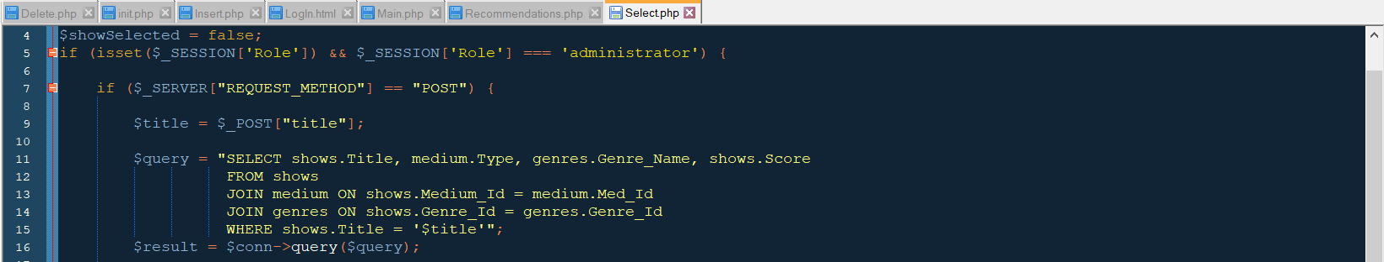

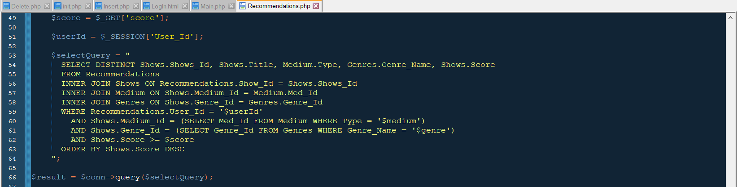

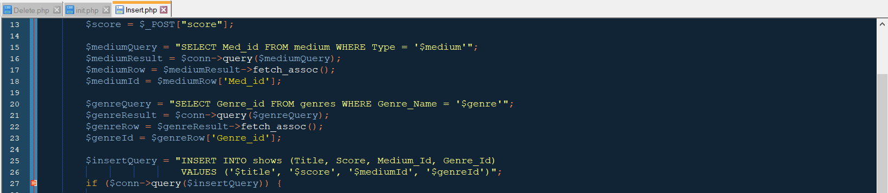

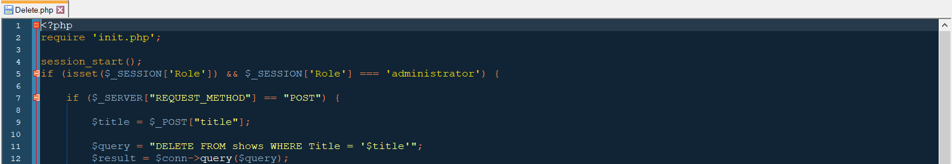

**4. Bibliography**

<https://www.w3schools.com/php/func_mysqli_init.asp>

<https://www.w3schools.com/sql/sql_view.asp>

<https://www.w3schools.com/sql/sql_top.asp>

<https://www.w3schools.com/sql/sql_null_values.asp>

<https://www.w3schools.com/sql/sql_join_self.asp>

<https://www.youtube.com/watch?v=CzDQIGm_HOk&ab_channel=AzharTechnoCoder>

<https://www.youtube.com/watch?v=scd8YKiuS7I&ab_channel=Simplilearn>

<https://www.youtube.com/watch?v=YcLHapPnDQg&ab_channel=1BestCsharpblog>

<https://www.youtube.com/watch?v=_w6N_nplmAw&t=631s&ab_channel=DaniKrossing>

<https://www.youtube.com/watch?v=3CS-eQdcMLU&ab_channel=DaniKrossing>